Volume 8
Editors: Dr. Zainib Ahmad, Dr. Naseera Ahmed
Webmaster: Dr. Mujahid Ahmad Saeed

In the Quran Allah tells us about the future of Islam
“He it is Who sent His Messenger (Prophet Muhammad) with the guidance and the true religion, that He may make it overcome the religions, all of them, though the polytheists (believers in many gods) may be against it.”

Al-Saff : The Ranks, verse 9.

What a wonderful verse of the Quran that tells us what Allah has planned about the religion of Islam! Allah tells us that He intends Islam to be the major religion of the world. Alhamdolillah!
Allah also tells us that those who choose not to believe in Islam will not be happy by the success and spread of Islam, and they will try to oppose Islam. Even so Allah will help Islam and it will spread throughout the world.

Almost everything in the world follows cycles of up and down, less and more, progress and decline. If we learn about the history of Islam, we will find out that there have been good times and bad times. What we need to remember is that the promise of Allah to help Islam and to make it the main religion of the world, depends on how good we are at following Islam. If we only call ourselves Muslim and then do whatever we wish to, we are not following Islam.

Ask your parents to help you find out when this verse of the Quran was revealed.

Do you think it was revealed when Prophet Muhammad (pbuh) first became a Prophet and lived in Meccah, or when he migrated to Medina?
Clean those choppers
by Mrs Munira Rahman. San Diego, USA.
Oh the joys of friendship! You can’t wait to meet your best friend on the bus and talk to him about the new Mario Zipzapper game, but as soon as he sits next to you and leans over to talk, a whiff of really bad breath floats your way. You wrinkle your nose and move back. He is so excited about the game he keeps yapping all the way to school but you do not hear a word he says. You are too busy holding your breath and trying to edge away from that not-so-great-friend of yours.

Now imagine yourself at the age of 65. You have finally retired; no more school, no more jobs. This is the life! You decide to eat Caramel Apple Nutty-O’s ‘the crunchiest cereal to munch’ for breakfast, but there is one slight problem. You cannot find your dentures. It is hard to eat with just gums…..(which is why babies just drink milk). You sigh, as you stare at the cereal box. If only you had brushed your teeth better when you were young….. If only………

Need I say more about the importance of brushing your teeth and tongue well? These two Hadith, which show how much importance our Prophet Muhammad (pbuh) gave to cleaning the teeth.
1. Never did the Prophet (pbuh) wake up after sleeping at night or in the day, but he used the tooth-brush before he performed ablution (wudhu).
2. When Hazrat Ayesha was asked what was the first thing the Messenger of Allah (pbuh) did when he entered the house, she said, “Tooth-brushing”.
If we clean our teeth often and regularly so many diseases can be avoided. Our breath will smell fresh and we will feel healthy. So grab a toothbrush and some minty toothpaste and give your teeth a good brush. Don’t forget your tongue!

A Hajj Story
By Dr. Hamid Rahman. California, USA

Fatima was sleeping snugly in her bed when the sound of her alarm clock jarred her up. She glanced at the window and saw that the darkness beyond the curtains was faintly aglow with the breaking dawn. Fatima always found it difficult to get out of her warm bed for fajr prayers, but the thought that she must not keep her loving Allah waiting always made her throw off her covers and get up. But today was different. Fatima jumped out of the bed; a sense of excitement and expectation filled her.

“I have so much to do today, I must help Ammi (mother) after school to clean the house because Abbu (father) is coming back from Hajj in the evening,” thought Fatima as she rushed to the bathroom to perform wudhu.

Fatima loved her Abbu. She especially loved the time she was with him in the car as he drove her to school every morning. They would talk about everything, and Fatima knew that she had his undivided attention at that time. It was during one of these morning drives that her Abbu had told her,
“Fatima, I am planning to go for Hajj this year.”
“Oh must you! I am going to miss you,” she said. “How long will you be away?”
“About two weeks,” her Dad replied.
“I guess I can put up with that. Why must you go for Hajj?” asked Fatima.
“Well it is a long explanation, and we are almost at your school. But I promise you I will tell you all about it in the evening.”
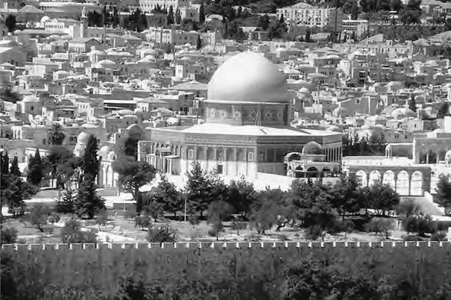

That evening, after dinner, Fatima reminded her Abbu about his promise and he said: “My dear daughter! Allah, Who has made us and put us in this world, has given us guidance in the Quran on how to be good human beings and be successful in life. A summary of this guidance is called the Five Pillars of Islam. Do you know what they are?”
“Yes! Yes!” Fatima answered quickly, “Ammi has taught me the Five Pillars of Islam. They are iman or faith, salat or prayer, siyam or fasting, zakat or charity, and hajj or pilgrimage.”
“Good job!” her Dad said, feeling very happy that she remembered all this at this young age.
“So, I guess, I need to tell you why hajj is on that list. The first house on earth made just for the worship of Allah was in Meccah which is now in the country of Saudi Arabia. Who do you think made it?”
This was a tough question for Fatima, but she reasoned quickly in her mind and said, “Adam? Since he was the first man”.
“Yes! Very good. Over many hundreds of years after Adam, the house was reduced to a rubble and Allah commanded Prophet Abraham to rebuild it and he did so with the help of his young son Ishmael, who was also made a prophet by Allah later on.”
“How interesting!” Fatima said.
“This ancient house, which is called Kabah is a symbol of the unity of Allah – that there is no god but Allah, and it is symbol of the unity of mankind – that however different we may look, we are all descended from the same father Adam and the same mother Eve. So Allah has commanded us to go for hajj, if we can afford it, to renew our faith in these two great truths – the unity of Allah and the unity of mankind.”

Fatima kept glancing at the clock that whole day in school. At times she thought the clock had stopped and was not moving. She tried to concentrate on her lessons but her mind kept drifting back to her Dad’s return. She wanted to ask him so many more questions about hajj. Somehow Fatima managed to make it through the day. In the evening, she put on her best dress and drove with her Ammi to the airport.

The airport was crowded as usual. People were milling around her, and with her child’s height it made it very difficult for her to see the arriving passengers. Fatima wanted so much to spot her Abbu before her Ammi did. She kept straining her eyes. Eventually she saw a strange man coming towards her and waving to her. She turned to her Ammi, and said, “Why is that man waving to us?”
“Why? Because he is your Abbu, he is back from hajj!” she exclaimed.
“But what happened to his hair? Why is he bald?” enquired Fatima. But there was no time for an answer because the stranger – actually Abbu – had reached them and was holding both of them in a warm embrace.

Fatima could hardly wait to get back to the car. She must solve the mystery of what happened to her Dad’s hair. As her mother drove out of the parking lot, Fatima gave a quick thank to Allah that her Dad was back, and also for the fact that they had one of those cars where she could sit between her Mom and Dad on the front seat. This way she could be close to both of them, and did not have to shout her questions from the back seat.
“Abbu! What happened to your hair?” she asked.
“My dear, it is a tradition of the Holy Prophet Muhammad (pbuh) that when the pilgrims return from Arafat to Mina and have stoned the devil, the men pilgrims shave off their hair.”
“Arafat? Mina? Stone the devil? But I thought you had gone to Makkah to visit the Kabah,” said Fatima, now more confused than ever.
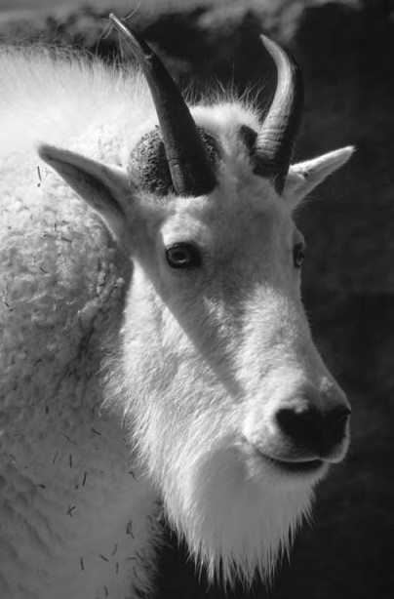
“Yes that too!” her Dad replied, “You see, there are many things a pilgrim has to do before the hajj is complete.”
“Oh really! Are they difficult to do?”
“Yes, some of them are,” he said.
“Which one is the most difficult?” she asked.
“Easily, the stoning of the devil,” he replied.
“Did you actually see the devil?”
“Oh no!” her Dad laughed. “It is just a symbol. There are three pillars that have been made at the place where the devil tried to tempt Prophet Abraham to disobey the command of Allah to sacrifice his son Ishmael. The stoning of the devil is only a symbolism to keep the devil at a stone’s throw from you at all times.”
Fortunately, Fatima had heard the story of how Allah had commanded Prophet Abraham to sacrifice his son Ishmael and both of them had obeyed. Just when Prophet Abraham was going to sacrifice his son, Allah commanded Prophet Abraham to stop and instead asked him to sacrifice a sheep. Fatima knew that at the time of Eid-ul-Adha, they always sacrificed a sheep to remember the sacrifice of Prophets Abraham and Ishmael. Fatima had many more questions, but she was getting drowsy. The purring of the car as it sped down the Freeway was making her very sleepy. She had been up since early that morning and had worked hard helping her mother clean the house as well. Her Dad was not going anywhere, and she would have plenty of time to ask more questions. She let her head drop on his shoulder, closed her eyes and drifted off to sleep.
Ha Ha, Ho Ho
What do ogres eat for dessert?
Spittles!

Why did the boy try to climb into the mailbox?
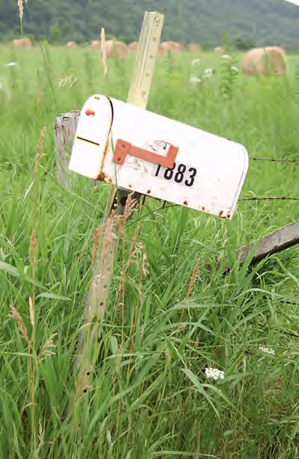
Because he thought he was male (mail).

What goes up and down in a flash?
A kid doing salat too fast.

Why was the centipede late for salat?
He wanted to wash all his 100 feet.

What is very aggravating?
The Niagra-vating falls.

Knock-knock.
Who’s there?
Interrupting cow.
Inter-.
Moo!

Knock Knock
Who’s there?
Lighthouse
Lighthouse who?
Sigh, you really need to start reading the magazine…….

What’s orange and sounds like a parrot?
A carrot!

Girl: Did you hear that the police caught a man with one eye called Bernie?
Boy: What’s the name of his other eye?

by Dr Ayesha Khan. Michigan, USA.
Ask Ayesha and she answers your questions

My mom and dad say fighting is bad and they don't let me get video games that have fighting in them? But the Prophet Muhammad used to fight in wars, and the Quran talks about fighting, so why is it bad for me?
Dear Ferocious Fighter,
Do you know what the word Islam means? It means peace. It is named peace for three different reasons. First of all, we have to be at peace with Allah—this means doing the things Allah has told us are good for us and staying away from things that are not good for us. Secondly, we have to be at peace with our fellow human beings. This means being kind to them and never hurting them. Thirdly, Islam is called peace because when you do these things, your own heart gets filled with peace and happiness. You are right that the Quran does talk about fighting. It actually talks more about not fighting. In the Quran, Allah makes it very clear that you can only fight in self-defense. Only if someone is trying to hurt you, can you defend yourself and even then as a last resort.
All the wars the Prophet fought in were in self-defense. For many years, he lived with all kinds of mean people who were trying to hurt him and never did a thing to fight back. Do you know there was a mean lady that used to throw dirty garbage on the Prophet every time he would walk by her house to go to the mosque. He never said one word to her but just took all her mean behavior and ignored it. One day, she was not there to throw garbage at the Prophet and you know what he did? He went to her house and asked if she was feeling OK because she had not come out to throw garbage on him! He was worried she might be sick! That is how much love we should have in our hearts for other people—even when they do mean things to us, we should try and do nice things for them.
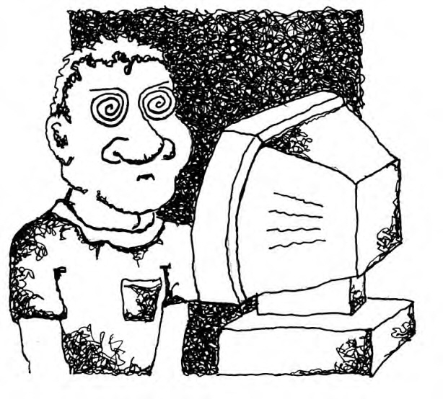
You are right when you say that the Prophet fought in wars. But as I told you, he put up with a lot of mean stuff from people. Only when Allah saw that the mean people the Prophet lived with were getting too out of control did He tell the Prophet it was OK to fight in self defense. That is because the mean people were doing horrible things like torturing Muslims just because they said, "We believe there is only one God." That is a pretty big deal. So next time you feel like fighting with your brother and sister, just remember, Allah wants you to put up with a lot of stuff before you're actually allowed to fight.
As for video games, your parents probably don't want you to get used to seeing all the violence in fighting games. When we see things that aren't good all the time, we get used to them. And pretty soon, we start to think they are OK. That is why Allah has told us to avoid even being around things that aren't good.

Dear ayesha apa, I have a strange problem, when I start to pray in my room, I start to feel scared. I think there is someone behind me, like Voldemort or death eaters....and then I cannot concentrate on my salat. I just rush through it, please help me.
Dear Scared Silly,
Allah has told us that we don't need to fear anything but Him. That is because Allah always protects us as long as we behave like good Muslims and do good things. So how would He ever let anything bad happen to you when you are praying?
Let's see if I can come up with some more practical tips for you.
Have you tried praying in a different room?
How about praying with the lights on?
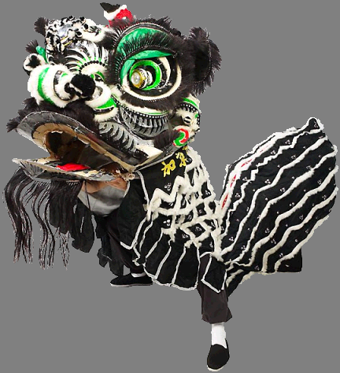
How about praying in the living room when your mom is in the kitchen?
Try these tips. But most of all, remember nothing is more powerful than Allah. Not Voldemort, death eaters, brain busters, life-leaching toads, soul-sucking goats, mind-melting meatpies, fungus festering flies, or your math teacher! If Allah wants to, He can make them all disappear faster than the blink of an eye.
My Ami taught me a prayer when I was little and got scared: "SubhanAllah wa bi humd-i-hi. Subhan Allah hil Azeem" It means, “Pure and perfect is Allah and all Praise belongs to Allah, Pure and perfect is Allah, the Mighty”. She told me that if I repeated it, Allah would send hundreds of angels to surround me and protect me. Now that I've grown up, I know that she meant that if I pray to Allah, he will surround me with His protection. And that is my secret weapon. So come on you stinky Voldemort, let's see you try to get me!

WONDERING ABOUT SOMETHING?
ASK AYESHA AND GET AN ANSWER THAT HELPS YOU TO PUT YOUR MIND AT EASE
Write to us at zamustang@msn.com
Riddles

Answers are given on the last page but don’t peek…….

You do me every day,
But don’t try to rush
You need me before you pray
So go ahead and wash, wash, wash
What am I?
I call you to get ready
I remind you when you forget
The times are fixed you know
Repeat my words and you benefit
What am I?

Hide me if you can in a tree
I will find a way to come out
I won’t go away unless you say the special words
I give you a bad feeling so stay away from me
What am I?

I am new, shiny and curved
Look for me every month
I am special and lots of fun
Greetings of peace and blessings everyone
What am I?

We are best friends
Add us together and we make the number 10
Multiply us and we make the number nine?
What numbers are we?

A Trip to the Philippines
by Mrs Samina Malik. Ohio, USA.

Dear Children,

I want to talk to you about last month. I was in the Philippines for two weeks. It would be fun to go to an atlas, or your computer and find out where the Philippines is.

The Philippines is made up of many islands. One of the islands is called Mindanao. There are many Muslims in Mindanao, whom I visited and they are very nice people. My main reason for going there was to take Islamic books to the people there. They need our books about Islam. They especially need the English translation of the Holy Quran.

The children there are very good Muslims and they try their best to say their daily prayers. At one of the meetings a little girl sang a song about Islam, and she wanted me to listen to her. I just loved her song. When I see the Muslim children in Mindanao, I see that they do not have all the material things that we have. We thank Allah that we have so many things. But although these children do not have all the material things in life, they do have a very precious gift from Almighty Allah and that is Islam and the Holy Quran.
I would like you all to pray for those little children so they can also have good things in life. There are some children, who lost their parents, and they are alone, and other good Muslims take care of them. The children who have their parents are very lucky to be with their parents. So all the children should be kind to their parents. We have to listen to them and love them also.
If you have toys which you do not need, you can send it to us and we will send them over to your brothers and sisters in Mindanao. This way we can share things with others. Our beloved Holy Prophet Muhammad used to share everything he had with those people in need. Allah the most High loves those children who share things with others. I feel so good when I share my things with others and I am sure that you will also.
I would like to tell all you dear children to say your prayers and always try your best to read one line of the Quran every day if possible. If you can not read it then tell your parents to read it for you. Allah loves the children who read the Holy Quran.
Guess what I saw in Mindanao! I saw a humongous lake which is the largest lake of Philippines. Can you find it in the map?
Inshallah, I will be traveling again to other countries and I will be bringing more news to you all.

For the time being, Assalaamu alaikum! Please pray for me, and May Allah the most High be with you all.

Answers to riddles
- wudhu, adhan, bad deeds, new moon, one and nine.

Brown is the color of the earth,
The squishy mud,
Where all the seeds grow,
Brown is the color of my eyes
and the color of chocolate
Yum yum
Brown is the color of my hands
and the color of acorns
Small and hard
They grow into GIANT oak trees
Strong and TALL
Brown is the color of my face
I love the earth,
Every bite of chocolate
And all the acorns
I love the color of all people
And I love the color of ME.

