Lighthouse Magazine Volume 4
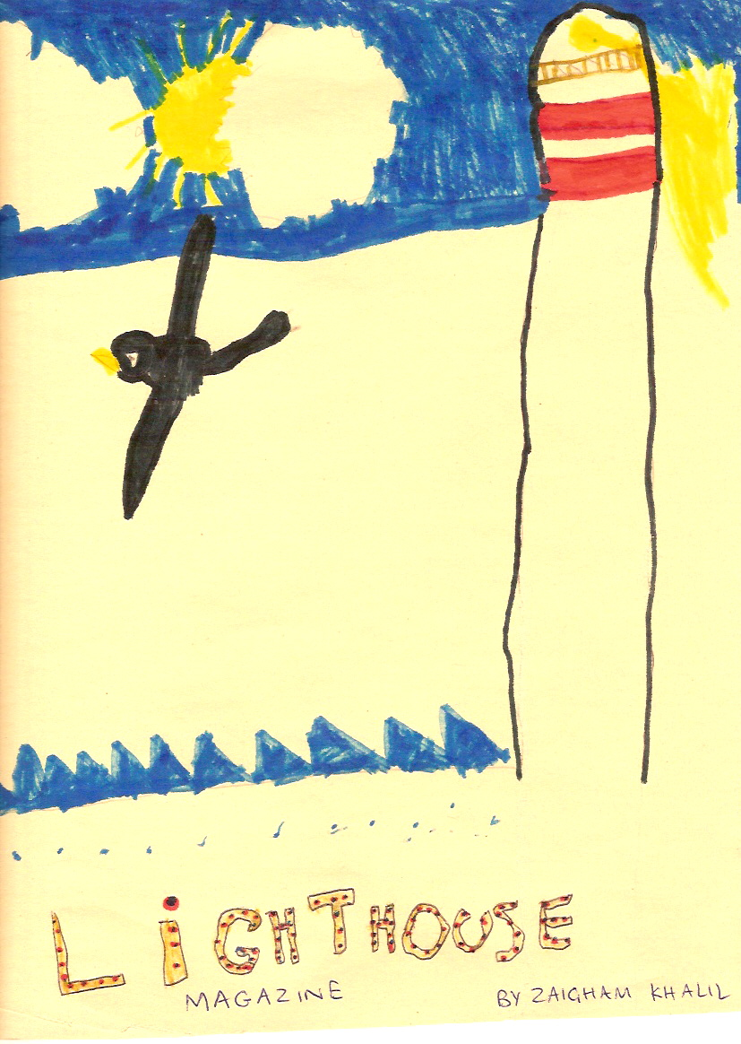

Light from the Quran

“O you who wraps himself up. Arise and warn. And magnify your Lord. And purify your garments. And shun uncleanness. And do no favor seeking gain.”
Al- Muddaththir: The one wrapping himself up. Verses 1-6.

These are verses revealed to the Holy Prophet Muhammad (peace be upon him) in Makkah, soon after he was made a prophet. He is told that his job is to warn other people and praise Allah. The importance of being clean at all times is clear from these verses. Of course these verses are sent to the whole world and not just the Prophet Muhammad (pbuh).

What do you think we are wrapped up in?
What is it that we spend all our time on?
Are we taking enough time out of our activities to do what Allah has told us to?

The last verse tells us that the aim of our good deeds should be to please Allah and feel happy about it. It does not really matter if the person we tried to help is ungrateful or no one noticed our good deed. Allah always notices. We should try to focus on the presence of Allah in our lives.

Each time we make a good choice in school and we remember to be kind and gentle to others, we are remembering Allah.

Humor of the Prophet Muhammad (pbuh)

By Mrs Munira Rahman. California, USA.

Our Holy Prophet Muhammad (peace and blessings of Allah upon him) had a great sense of humor, and was very witty. He was once sitting with his cousin, Ali, eating dates out of a bag. The Prophet (pbuh) thought of playing a joke on his cousin. After eating a date, he would quietly slip its stone into the pile lying in front of Ali. When they had finished eating the dates, the Prophet (pbuh) remarked. “Let us see who has eaten most of the dates.” Surely the pile of date-stones lying in front of Ali was bigger. On this the Prophet (pbuh) smiled. However Ali, realizing the joke, replied “Ah sure, it seems you were so hungry that you ate the dates along with the stones!” On this, both of them burst into laughter.

Humor, or being funny, is a great way to enjoy the blessings of life. The Prophet (pbuh) showed us that we can be funny and have fun without hurting anyone’s feelings.

In this issue we are starting a new series called ‘Ask Ayesha’. You can send your questions to Dr. Ayesha Khan, of Michigan, USA and she will help you with your problems, using Islamic knowledge as her guide. Please send in your questions as soon as possible so your questions and their answers are included in the next issue of Lighthouse Magazine.

Dear Ayesha,
I often forget to say Bismillah when I eat something. At home my mom reminds me but as school somehow I always forget. Do I always have to say Bismillah before I eat? How can I remember?
Forgetful Fatima.

Dear Forgetful Fatima
It is good to say the name of Allah on the meat you eat because it reminds us that Allah creates all life and only He has the right to take a life. But for our ease and so we can enjoy good food, Allah has given us permission to kill animals we are going to eat. So that we remember this is a favor from Allah and that it is with his permission that we are going to eat this meat, we should say Allah hu akbar before we eat it. Also, before we eat any food, we should say Bismillah because it is a great blessing that Allah has given us that food. I think it is great you are trying to remember to say these things at school too. I have trouble remembering things too. Sometimes, I write a reminder on my hand so when I look at it, I will remember what I had to do. For example, you can put a “B” on your thumb with a ball point pen so when you are about to eat, you will see the “B” on your hand and remember to say Allah hu akbar and Bismillah.

Dear Ayesha,
I love to play on the computer and with my Nintendo. As soon as I am in the middle of something my Dad calls me to pray and I get upset. It is very hard for me to leave the
game and come back. Can you help me?
Computer Champ.

Dear Computer Champ,
You ask a good question. There is a simple answer, and a tougher answer. I’ll give you both. When I was younger and prayer used to get in the way of my Nintendo (yes they had Nintendo even when I was little!), I would pause it and come back to my same game. But of course the more important question here is what is more important, prayer or other stuff? I know you think, well I can always pray later but what happens if you get really busy or have to do something else and your prayer gets missed? That’s no good right? That is why Allah has told us, that as soon as we hear the adhan or call to prayer, we should drop everything and pray. In fact, did you know that the actual translation of “Allah hu Akbar”, the words repeated in the adhan, is “God is greater”? That is to remind us that God is greater than anything we are doing. And the adhan goes on to say, “Come to prayer. Come to success.” This reminds us that if we pray we can be successful because when we are praying, it is our chance to talk to God. We can ask Him all the things we want to ask and to get all those good qualities that will help us advance spiritually. Prayer is our chance to get our spiritual energy refueled so we can go on in life and get more spiritual points. Make sure you don’t lose the points that really matter!

Dear Ayesha,
My uncle told me how important it is to pray and I am trying hard to do it. But as soon as I start I get distracted and start thinking about other things. Usually I forget what part I was on. How can I get better at it?
Distracted Dude.

Dear Distracted Dude,
It’s very good that you try to pray. I know it’s easy to get distracted but keep trying—that is the most important thing. One thing that might help is to learn the translation of the salat so you can focus on the meaning of what you are saying instead of not being sure what your words mean. Hope that helps! Another way would be to pray in your room with the door closed, instead of in the family room where it is noisy with people talking and the telephone ringing. Put a sign on your door saying, ‘Do not disturb me. I am praying’.

In Volume two we asked out readers to ‘complete the story’ where a girl went camping with Girl Scouts, and felt awkward leaving the campfire and getting up to pray. Zaigham Khalil from Ohio, USA sent us the following ending
She turned to her mother and said, "I want to pray because good Muslim people should pray every day five times a day." Ayesha and her mom prayed together and then they said a dua. After that they ate dinner.

JazakAllah Zaigham, for giving such a great ending to our story. I am sure all the girls scouts were interested to see them praying and asked what they were doing. They must have learnt more about Islam.
Ramadan Resolutions by Zaigham:
-Take extra care of my brothers
-Be more helpful to my parents
-Increase my number of prayers that I say daily
JazakAllah Zaigham! Keep up the good work. We love to hear from young scholars like you.
Lucky
Habiba creeped out of bed quietly and tiptoed to the bathroom. She was sure she would make it today before anyone else and then would not have to wait or rush. Even before she twisted the door handle she heard water splashing inside. She sighed and shook her head. Haneefa, her sister, had beaten her to it. Now she would take ages and Habiba would have to wait. Her Mom was sure to be in the other bathroom getting ready for work. I am never lucky she thought glumly. Now my brothers will grab all the Coco Plops and I will have to eat cornflakes for breakfast. And if I am the last one eating I will have to do the dishes too.
She went to her Dad who was sitting at the computer as usual, a frown on his face.
“Assalamu alaykum Dad,” she said, “do you remember you promised to drive me to Maya’s house this morning?”
Dad kissed her cheek and then closed his eyes. “Is Maya the snobby kid who lives at the North Pole?”
Maya rolled her eyes. Her Dad was always cracking jokes. Even after he had lost his job two months ago, he never let his kids know how worried he was.
“Dad, she just lives about fifteen minutes away. And she is not snobby, just rich and lucky, ok. She is an only child and lives in this huge house.”
Not like me, she thought, who has one sister and two brothers and we live cramped up in this town house.
“Ok, ok, dear, but first can you bring me a bowl of cereal and pray that Allah makes things easier for me in my job search,” said Dad.
“I will,” said Habiba. She felt better now. I might be a bit lucky to have a friend like Maya, she thought. Four bathrooms and only three people in the house! She could even use two bathrooms at the same time!
It was starting to get dark when Maya’s mother dropped Habiba home. She was glad to see her mother in the kitchen, stirring something on the stove. She looked tired. Habiba hugged her and told her about the great time she had. Then she sniffed the air. “What’s for dinner?” she asked.
“Kidney beans and chicken salad,” said her mother.
“Oh, can’t we go out to eat mom? Maya’s family eats out two or three times a week. Today she ordered pizza for us and pie from Baker’s Square and they were going out to a fancy restaurant for dinner.”
Habiba’s mother sighed. Whenever Habiba spent the day with Maya, she came home and grumbled about everything. Money had been tight since Mr. Khan had lost his job, but the family had much to be grateful for. She did not feel like arguing with her daughter and decided to distract her instead.
“Habiba dear, can you please check the mail for me and sort it out?”
Habiba headed outside with an injured look. As usual there was a jumble of catalogs and advertisements. She dumped them all in the recycling box. Of course we can’t afford catalog shopping, she thought, and Maya just got a bunch of stuff from the American girl catalog. One envelope caught her attention. It had pictures of children on it.
“Mom should I open this for you?” she asked.
“Yes, I think it may be a letter from Parveen. I hope it is good news”.
Inside was a letter that had been translated into English, and some photographs. Habiba began to read the letter out.
“Dear Sponsor family. Greetings of peace. I am doing very well and am very grateful for your help. The most exciting news is that we have been able to build our very own bathroom with running water. It will help us so much in the winter. My mother is better now and she says soon I may be able to go back to school. My elder sister got married and she gave her old shoes and shawl to me. Now I have two pairs of shoes! My brother said that if his vegetable stand does well he might buy some socks for us all for the winter. I am busy all day taking care of Asif, Arshad and Amina. I found a crayon on the road and so I am sending a drawing for you. I pray for you every day.
Love, Parveen.”
She put the letter down feeling she had a lump in her throat. Her family had all gathered for dinner. She held up the drawing Parveen had made of eight stick people inside a box like house, all with huge smiles on their faces. Next to the house was a small box with a star on it. That must have been the bathroom.
“I didn’t know you sponsored a child,” she said quietly. “I thought we did not have a lot of money.”
Her Dad smiled at her and said, “we really do not have a lot of money right now Habiba, but we have a lot of blessings from Allah. We still think we have enough to help other people out - those less fortunate than us and there are so many people like that.”
Oh, thought Habiba, I keep thinking of those who have more than us so I always thought we were unlucky and other people were better than us.
“Remember that huge earthquake in Pakistan a few years ago?” asked Haneefa, “well Mom and Dad decided to sponsor a child in that area to help them out. So many people were killed but the ones left behind are those who need the most help. This family’s house was destroyed and their uncle was killed, so they needed a lot of help. Thankfully now they have their own home, even though it is small and they did not have a proper bathroom till now.”
“What did they do without a bathroom”, asked Habiba sadly.
“Well people in villages just have to use the fields as their bathroom. But that can be hard when it is very hot or cold. And imagine getting up in the middle of the night to go to the fields to go potty”, said her brother Anas. He was teasing Habiba as she was scared to use her own bathroom in the night and always woke her mother up.
Habiba scowled at her brother. She was always being teased as she was the youngest of the family.
“How was your day with Richie Rich?” asked her other brother Hamid.
“Her name is Maya,” said Habiba gruffly.
“Maya is a very nice girl, Habiba,” said her Mom, “but dear don’t try to compare yourself with people who have more stuff than you do. Try to think how lucky you are by comparing yourself with those who have much less and that will make you feel grateful for the blessings you have in your life”.
“Yeah, like Maya does not have fantastic brothers and average kind of sister”, said Hamid.
“Average sister?” growled Haneefa, “well for your information, this ok sister just won the Gondal scholarship”.
Everyone cheered for Haneefa and soon she was being hugged and patted by her large family. Habiba watched and felt that it was nice to belong to a family that was happy and caring, even if they were not rich like Maya’s family. After all how much fun could it be being an only child. Maybe Maya envied her family.
“Hey Habiba, don’t you want ice-cream?” yelled Anas. “Haneefa is treating us all”. Habiba scrambled off the chair and ran to race her siblings to the car. It would be a squeeze with all of them, but who cared. They had two whole bathrooms and they were rich!
How to make time for prayers in our busy,
crazy life
by Mr. Akram Ahmad, Minnesota, USA

Keeping up our Islamic traditions must have been a bit of a challenge in the olden times, but it is especially so in our world of today. We live in a fast-paced time where days and weeks seem to fly by us. As a result, it is even more important to decide to make time for things that are the most important.

To illustrate what I mean, let me try to give you a few examples. Our weekly congregational prayer, the Juma, takes place on Fridays, while the children are attending school or college. What to do in this situation? It would help if we could clone ourselves for an hour or two, so one of us could keep doing its worldly jobs, while the other headed for the mosque. As that is not possible we have to follow Allah’s command in the Qur’an and leave our work, play and business to head for Juma.

We spend a large part of the entire week in good worldly pursuits. Going to school is very Islamic. Allah wants us to learn as much as we can and use that knowledge to help others and make the world a better place. Similarly earning money is a good deed. But the Juma prayer is a good deed that is better and more important than all the others. If we involve our selves in so many activities that we do not have time for our prayers, it means something has gone wrong and we have lost our balance in life. It is Allah Who has blessed our lives with all types of goodies and comforts, so we should at least devote some of our time each week to participate in the Juma and thus show our gratitude to our Creator.
In our family, we send notes to our children’s teachers telling them about Juma and its importance, and then we request permission to bring the children home during lunch and recess to pray with us. It is a bit of a time squeeze, but we all hurry through lunch and have juma with short khutba’s or sermons given by myself as well as by both children. This gives them the chance to show us what they have learnt about Islam or to recite surahs they have memorized. We do not go to the mosque often, as there is none very close to us and it would take too long. When the children have vacations we take them to the mosque.

That was about the weekly congregational prayer. If you now look at the five daily compulsory prayers (Fajr, Zuhr, Asr, Maghrib, Ishaa'), you may think, what to do when it is time to pray and you are at school or camp? We have to be creative and find time, for pray we must. I know a ten year old boy, Hamza, who for the past two years has been fasting in Ramadan. During this holy month, he takes a prayer rug with him to school and when the other children go for lunch, he stays behind, with the teacher’s permission, and offers his zuhr prayers in the class. He is a splendid example of the fact that Allah has made us Muslims to live among Christians, so that we can be an example to them, NOT so we can pick up their habits and ways.

When I am at work all week long and it is time to pray, I perform the Zuhr and Asr prayers right at my workplace sitting at my chair and desk, during the lunch-hour. Speaking for myself only, I believe that Allah understands the problems we face. I wish there were a mosque at work where it were easy for me to pray but as that is not the case, I make the best of my situation and hope to please Allah by this. As Maulana Muhammad Ali noted most eloquently in his marvelous book - Living Thoughts of Prophet Muhammad - our soul needs (spiritual) nutrition, just as our body needs (physical) nutrition. Our beloved first president of the Lahore Ahmadiyya Jama’at, Maulana Muhammad Ali, further noted that the daily prayers, especially the daytime prayers, draw us out of our usual activities, and place us at the door of Allah so we may be blessed with food for our soul.

Praying regularly is not easy for children. It may seem very hard at times when there are many other things to do that seem urgent. However as Professor Dumbledore said to Harry Potter, sometimes we have to decide between what is good and what is easy.

May Allah help us all to make the right choices. May He make the salat as easy, natural and important to us as breathing – and eating desert!
Make up a Quiz competition:
Would you like to make up a quiz for your Muslim brothers and sisters? Now is your big chance. Think up any kind of Islamic puzzle or quiz and send it to Lighthouse Magazine. The winner will have his or her quiz published in the next issue as well as receive a mystery prize.

The winner of our ‘Cover Design contest’ is Zaigham Khalil from Ohio, USA. Zaigham is 7 years old and is in second grade in Dayton, Ohio. His prize money has been mailed to him.

The Blessed Messenger of Allah once asked a group of Sahaba (companions of the Prophet), “Which people’s faith do you think is most pleasing?”
One person suggested that the Angels had the most perfect faith. The Blessed Prophet replied, “But why shouldn’t they believe when they are with their Lord?”
Another person said that maybe the Prophets had the best faith. The Blessed Messenger answered by saying, “Why shouldn’t they believe when they have revelation descending upon them?”
Then another Sahaba suggested that maybe they, themselves, had the best faith. But the Blessed Prophet replied, “But why shouldn’t you believe when I am among you?”
Then he told the people with him, “The people whose faith pleases me the most are those who will come after my time who will find pages contained in a book (the Qur’an) and they will believe in what is contained within it”
(From the book of hadith related by Tirmidhi)
HOW GREAT ARE YOUR MANNERS?

The Prophet Muhammad (pbuh) said that the best person is the one who has the best manners. Who wouldn’t want to have the best manners? That is surely something to work towards.
Take this simple quiz and figure out how good your manners actually are:

- You are dashing home from the bus stop when you spot your elderly neighbor through the corner of your eye, walking toward you. You
- run straight home with your head down, pretending not to see him, as you don’t want to miss your favorite show
- yell ‘hi’ at him as you flash past
- stop for a few minutes to talk politely with him, asking him how he is doing and telling him about yourself. Missing a few minutes of T.V. won’t kill you.
- Pull out your lunchbox to offer him the squished remains of your peanut butter sandwich

- Your Dad comes home from work so you
- run to the door to ask if he has brought something for you
- stay in your room doing ‘whatever’ and wait for him to come and greet you
- run to say salam and hug him and ask him how his day went
- jump upon him, yelling with joy, almost knocking him over flat.

- Your mother meets an old friend in the grocery store and starts chatting. You can’t wait to get to the cookie aisle so
- you wait patiently for your mom to finish talking and politely reply when you are spoken to
- you keep tugging at your moms sleeve and nudging her while looking as glum and bored as possible
- you look at your watch and remind the ladies that the garlic on sale and they should rush for it
- you wander away from your mom and try to make a pyramid out of apples

- Your aunt sends you an eid present from Kalamazoo, that you don’t like a bit so you
- just forget to say thank you, as the gift was silly anyway
- call her up to tell her that you are too old for bunny slippers and she should just send you cash instead
- write her a thank you card because she loves you and thought of you, and send her your latest school picture
- send her your wish list for next eid.

- You were about to play your favorite CD when the adhan begins, so you
- listen quietly to the adhan, repeating the words to yourself.
- Run upstairs where you cannot hear the adhan and play your CD.
- Play your CD quietly while listening to the adhan with half an ear
- You plug in headphones and listen to your CD.

- Your grandfather is visiting you. He comes in the room and you are sitting on your comfy chair reading and your little sister is sleeping on the sofa. There is nowhere else to sit so you
- Don’t move but smile your cutest smile at your grandpa and ask him how his knees are
- tell him that you need to sit in that comfy chair to read properly
- push your sleeping sister to one side so he can sit beside her
- jump out of your chair to offer it to him, grabbing a floor cushion for yourself.

- Guests come over to visit just as it is time for Maghrib prayer. You
a. chat for a few minutes, serve them lemonade with your mom and excuse youself to pray. It only takes 5 minutes.
- decide to show them your latest art project. Prayer can wait while you are being a good host.
- wait and see if they want to pray. If they do not then you don’t pray either.
- Go to your room to play as you don’t like those people anyway

- Your grandma bakes you some special cookies that taste like glue and broccoli so you
- tell her that they taste awful, as it is always good to tell the truth
- slip the cookies down the front of your shirt as she is watching you, and tell her that they are the best cookies ever
- drown the cookies in your glass of milk and then secretly dump it all in the trash
- take a few small bites and thank your grandma for her love, telling her politely that she makes great chocolate cake.

- There is a big dinner at your house and you mom is super busy cooking and cleaning so you
- ask her how you can help by cleaning with her, making your super salad or organizing games for the kids
- ask her to make at least two of your favorite foods
- tease your brother and the cat as you are bored
- ask your mother to help you with a book report due tomorrow

10. Your brother got hurt when you accidentally hit him in the head with your ball. He is crying up a storm so you
a. suddenly decide that it might be time to pray and praying is good when there is trouble
b. shove a candy in your brother’s mouth so he stops wailing
c. try to comfort your brother and then call your mother and tell her what really happened
d. call your mother and tell her he bumped his head on the wall.

Here are the answers
1. c. 2. c. 3. a. 4. c. 5. a 6. d. 7. a. 8. d. 9. a. 10. c.
If you got
8-10…….. way to go. You really have super manners and are a joy to be around. Keep up the good work.
6-8 …………your manners are not too bad. They could do with some improvement though. Try to think less of yourself and more of others. It will make you feel good about yourself and make others like you more.
5 and below……oops, we need to send you to manners camp. Notice how embarrassed your parents get when you do just as you please. Think seriously about giving your manners a makeover. You can do it. Bad habits are hard to break but it can be done with prayer and sincere effort. May Allah be with you. Retake the quiz in a month and see how you did.
May Allah make us all one of those people whose faith pleases our dear Prophet (pbuh) the most! Ameen.

Acrostic poem by Aafia Ahmad, age 8, Minnesota, USA

Always forgiving
Loving
Living always
Arrahman
Helping and Kind

Remember to write to us lighthouseahmadi@gmail.com

